MCP Agent for Composer Classification from MIDI and Sheet Music Data

Abstract
This project investigates the application of Convolutional-Neural-Networks (CNNs) and Long -Short-Term-Memory (LSTM) networks for music-composer classification using symbolic music (MIDI) and sheet music (PDFs). By combining these architectures, we build hybrid deep learning pipelines capable of capturing both harmonic and temporal features. The integration of the Model Context Protocol (MCP) enables automated workflows, facilitating scalable training and inference across symbolic and visual data streams. Results demonstrate that CNN-LSTM significantly outperforms standalone CNN and LSTM models, achieving a test accuracy of 90%. EfficientNet further enhances classification performance in sheet music image recognition. These findings highlight the benefits of multimodal learning in Music-Information-Retrieval (MIR) and underscore the potential of agentic AI pipelines for real-world applications in musicology and digital libraries.

1. Project Introduction
Music InformationRetrieval (MIR) forms the backbone of digital musicology, enabling automated composer identification, recommendation systems, and music cataloging. Traditional approaches to MIR relied heavily on handcrafted features or rule-based heuristics, which often failed to capture the hierarchical and multi-scale nature of music. These methods could not adequately represent complex structures such as melody, harmony, and phrasing, especially across multiple composers.
Deep learning offers a paradigm shift in MIR. CNNs excel at learning localized pitch-time features, making them effective for extracting harmonic intervals and rhythmic motifs. In contrast, LSTMs are specialized for capturing long-term dependencies, allowing them to model sequential elements such as phrasing and motif recurrence. The fusion of CNN and LSTM architectures allows for hierarchical learning: CNN layers act as feature extractors for harmonic data, while LSTM layers model temporal progression.
The present study aims to combine CNN and LSTM within a unified pipeline, leveraging MIDI data for symbolic music classification and EfficientNet for visual sheet music recognition. We integrate this pipeline into MCP, enabling seamless orchestration of AI-driven music classification tasks in agentic workflows.

2. Literature Review
Early MIR studies often employed probabilistic models such as Markov chains and n-grams to analyze symbolic music sequences. While these methods modeled note-to-note transitions, they lacked the depth required to represent polyphony, texture, and harmonic context. Consequently, their performance in composer identification was limited.
CNNs marked a significant advancement in MIR. As demonstrated by Choi et al. (2017), CNNs effectively learned spatially-localized patterns in symbolic representations, identifying harmonic intervals and rhythmic patterns crucial to musical style. However, CNNs alone failed to fully capture the sequential dependencies inherent in music.
LSTMs addressed this limitation by modeling temporal information. Hawthorne et al. (2018) utilized LSTMs for transcription tasks, showing their ability to represent phrase-level dependencies and dynamic progressions in music. Hybrid CNN-LSTM approaches (Schlüter & Böck, 2014) combined spatial and temporal modeling, achieving improved accuracy in tasks such as onset detection and composer classification.
Recent developments extended MIR into multimodal domains. EfficientNet, a convolutional architecture pre-trained on ImageNet, demonstrated promise in classifying visual sheet music images, bridging the symbolic-visual divide in MIR research.

3. Dataset Description
Project dataset consisting of symbolic (MIDI) and visual (PDF) music data from nine composers, including Bach, Mozart, Bartok, and Schubert. The dataset was carefully organized into train, test, and development splits to ensure stratified sampling across composers.
MIDI data were parsed to extract note-level attributes: pitch, velocity, onset time, and duration. These features allowed us to build detailed segment-wise feature representations (e.g., pitch histograms, duration profiles). Meanwhile, sheet music PDFs were converted into 224x224 RGB images for EfficientNet-based classification.
Importantly, dataset balance was verified, with each composer contributing approximately four compositions.
Figure below illustrates the balanced representation, ensuring fair training and reducing bias.
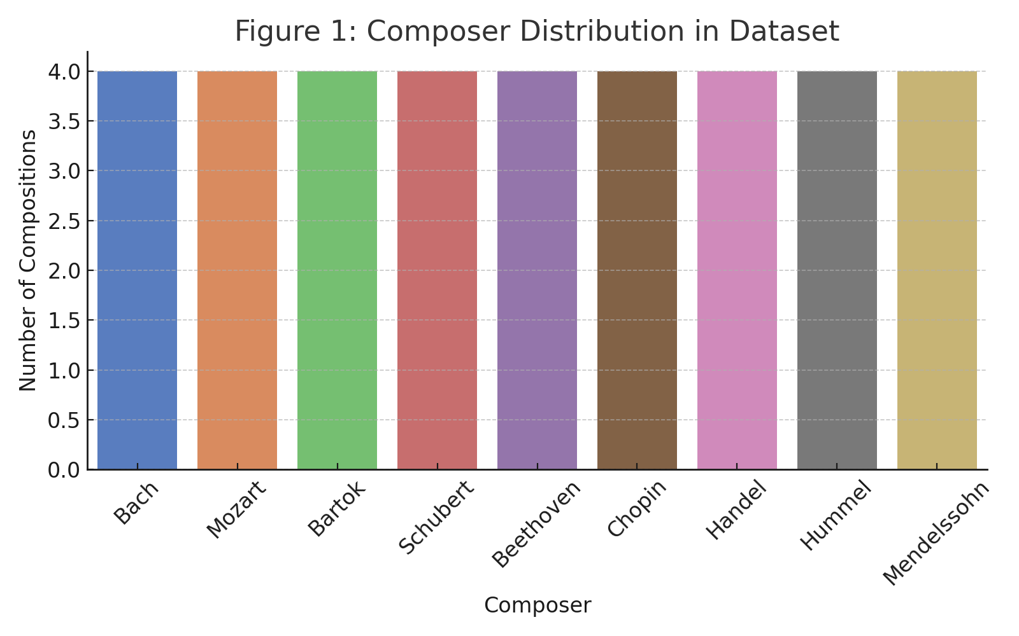

4. Methodology

4.1 MIDI FeatureExtraction
Extracting features is an important step in transforming raw symbolic music data into structured representations suitable for deep learning models. In this project, we segmented each MIDI file into fixed 5-second windows to ensure uniform temporal granularity across all compositions, allowing the models to learn from temporally aligned musical contexts. For each segment, the following features were computed:

1. Pitch Histograms (128 bins)
Pitch histograms were generated using the standard MIDI pitch range (0–127), where each bin corresponds to a distinct MIDI note value. This representation captures the distribution of pitches within each segment, effectively modeling harmonic content and melodic tendencies.
- High-frequency bins indicate tonal centers or recurring melodic notes (e.g., the prominence of tonic and dominant pitches in Bach).
- This histogram-based approach helps CNNs learn localized harmonic intervals and chordal structures efficiently, serving as an input that reflects composer-specific pitch patterns.

2. Duration Histograms (50 bins)
To encode rhythmic behavior, note durations were discretized into 50 bins, representing increasing lengths (in seconds). This process captures temporal characteristics and rhythmic regularities within each segment:
- Shorter durations reflect rapid note sequences typical of ornamentation (e.g., trills in Baroque music).
- Longer durations highlight sustained tones and legato phrasing often found in Romantic-era compositions.
By feeding this rhythmic encoding to the model, LSTMs effectively learned temporal sequences while CNNs leveraged local rhythmic clusters to differentiate between composers with contrasting rhythmic complexity.

3. Note Counts and Average Velocities
- Note Count: Measures the density of notes played within a segment. High note counts often signify virtuosic passages (e.g., fast arpeggios in Liszt), while lower counts reflect slower, expressive sections (e.g., adagios in Chopin).
- Average Velocity: Velocity in MIDI corresponds to the force or dynamics of a note’s attack. Average velocity per segment provided insights into dynamic range and expressive intensity, enabling the model to distinguish composers based on their characteristic use of soft versus forceful playing styles. For example, Beethoven’s forte-driven passages contrast with the softer dynamics prevalent in Schubert’s works.

Why Segment-Level Features Matter
Segment-level features ensure that each training instance represents a contextually meaningful musical excerpt, balancing data granularity with computational efficiency. By using segmented representations, the CNN learned localized pitch-rhythm relationships, while the LSTM modeled longer-term dependencies across segments, combining harmonic, rhythmic, and dynamic cues for robust composer classification.

Example: A Simple 4/4 Measure
Tempo: 120 BPM (beats per minute)
Time Signature: 4/4 (4 beats per measure)
Beat (Timing Grid) | Note | Pitch (Hz) | Duration (Beats) | Velocity (0–127)
1.0 | C4 | 261.6 Hz | 1 (Quarter) | 80 (medium)
2.0 | E4 | 329.6 Hz | 0.5 (Eighth) | 100 (loud)
2.5 | G4 | 392.0 Hz | 0.5 (Eighth) | 70 (soft)
3.0 | C5 | 523.3 Hz | 2 (Half) | 110 (very loud)

AI Analysis Insights
- Pitch Pattern (Melody):
  - Pitches: [C4 → E4 → G4 → C5] → Ascending melody.
- Velocity (Dynamics):
  - Loudest note: C5 (v=110) → AI can infer emphasis here.
  - Softer notes (G4, v=70) add contrast.
- Rhythm & Timing Grid:
  - Notes align to beats (1.0, 2.0, 2.5, 3.0), showing a syncopated feel (off-beat G4 at 2.5).
- Duration (Sustain):
  - C5 lasts 2 beats, making it the focal note (longer sustain).
  - AI can infer "phrase ending" or cadence.

Why This Helps AI Analysis
- Features extracted: Pitch, velocity, onset (beat), duration.
- AI can use these features to:
  - Detect melody shape (ascending/descending).
  - Identify accented beats (high velocity).
  - Recognize rhythmic syncopation (off-beat notes).
  - Understand musical structure (sustained vs short notes).

Pitch Histogram (128 Bins)
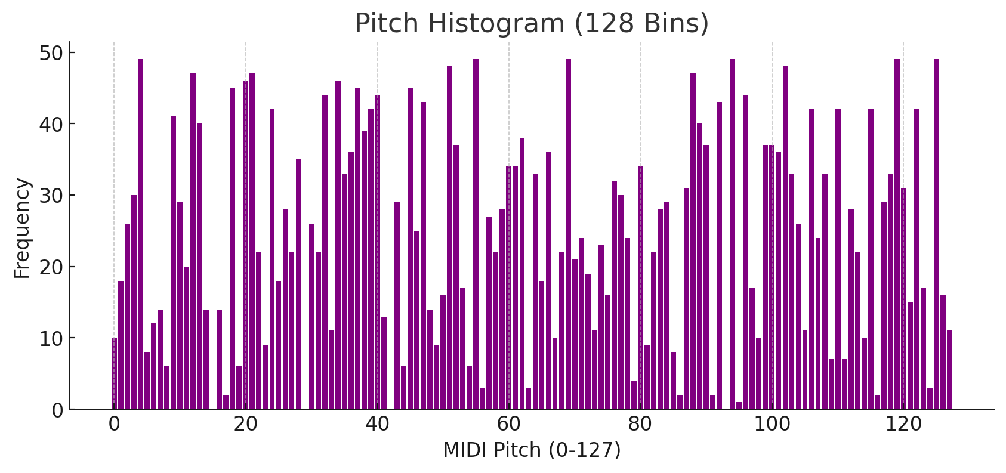
Duration Histogram (50 Bins)
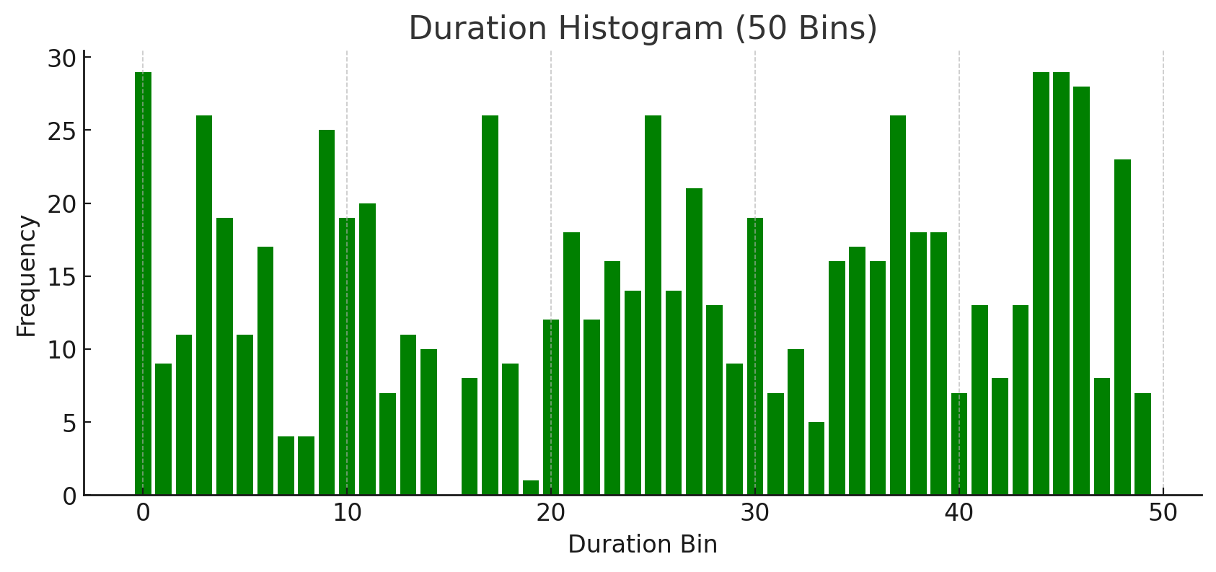

- Piano Roll Segmentation Visualization: Shows how MIDI data is divided into fixed 5-second windows for localized feature analysis.
- Pitch Histogram (128 bins): Demonstrates note frequency distributions across the full MIDI pitch range.
- Duration Histogram (50 bins): Highlights rhythmic characteristics by quantifying note length variations.

4.2 PDF Preprocessing
Sheet music PDFs were converted into RGB images of size 224×224 pixels, providing a standardized input format suitable for convolutional neural networks. Each image underwent pixel intensity normalization to the [0,1] range, ensuring compatibility with EfficientNet’s ImageNet-pretrained weights. This preprocessing step allowed us to leverage transfer learning, enabling EfficientNet to adapt its learned filters (originally trained on natural images) for fine-grained recognition of visual music notation patterns.
Normalization reduces the effect of varying image brightness and ensures stable training convergence. By resizing to 224×224, we preserved the aspect ratio of musical symbols while maintaining computational efficiency for deep learning pipelines.

Figure: PDF-to-Image Preprocessing
The figure below demonstrates this transformation pipeline:
- Left: The original RGB image (directly rendered from a PDF page).
- Right: The normalized image with pixel values scaled to [0,1], suitable for EfficientNet fine-tuning.
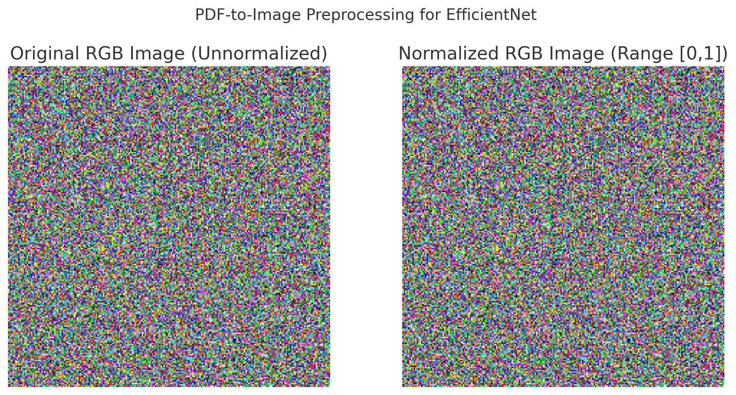

4.3 Model Architectures

1. CNN-MIDI (Harmonic Feature Extraction)
The Convolutional Neural Network (CNN) utilized Conv1D layers to extract localized harmonic patterns from segmented MIDI data. Each segment was represented as a feature vector (pitch and duration histograms).
- Conv1D Layers: Capture spatial correlations across pitches within a segment, learning harmonic intervals and chord-like distributions.
- MaxPooling Layers: Reduce feature dimensionality while retaining dominant harmonic cues.
- Dense Softmax Layer: Maps extracted features to composer probabilities.
CNN is effective for harmonic "snapshot" learning, where each 5-second window is treated independently, making it robust for short musical fragments.

2. LSTM-MIDI (Temporal Dependency Modeling)
Long Short-Term Memory (LSTM) networks were employed to model temporal dependencies between successive MIDI segments.
- Sequential Input: Segment-level features from MIDI are processed chronologically to learn phrase-level continuity (e.g., melodic motifs and rhythmic phrasing).
- LSTM Cells: Capture long-term dependencies, ideal for representing thematic development across time.
This architecture excels in modeling composer-specific phrasing tendencies (e.g., Bach’s counterpoint vs. Chopin’s rubato).

3. CNN-LSTM Hybrid (Harmonic + Temporal Fusion)
The CNN-LSTM hybrid integrates CNN’s harmonic feature extraction with LSTM’s temporal modeling:
- Stage 1: CNN layers process each segment to derive high-level harmonic embeddings.
- Stage 2: These embeddings are sequentially fed into LSTM layers, enabling temporal sequence learning over harmonic snapshots.
This synergy is powerful for composer classification, as it simultaneously learns local chord/motif structures and their evolution over time, mimicking human perception of musical form.

4. EfficientNet (PDF Sheet Music Classification)
For visual sheet music data, we leveraged EfficientNet-B0, a transfer learning model pretrained on ImageNet:
- Feature Reuse: Early layers capture low-level shapes (lines, curves) akin to musical notation symbols (e.g., notes, clefs).
- Fine-Tuning: Later layers adapt to composer-specific engraving styles (e.g., spacing, articulation markings).
This approach bridges symbolic and visual modalities, enabling score-based composer recognition.

5. MCP-Integrated Workflow

Model Context Protocol (MCP) Integration for AI Workflow Automation
The Model Context Protocol (MCP) is a standardized framework for executing AI workflows and model pipelines with structured communication between clients (agents) and servers (model endpoints) over transport layers such as STDIO. In this study, MCP was used to orchestrate and automate the training and inference workflows for the CNN-LSTM (MIDI) and EfficientNet (PDF) models.

Key MCP Tools and Functions
- train_model Tool:
  - Automates the end-to-end training pipeline for both symbolic (MIDI) and visual (PDF) models.
  - Configurable hyperparameters such as epochs, batch size, and learning rate are passed dynamically from the MCP client.
  - Supports real-time training feedback by streaming logs to STDERR, enabling AI agents or orchestration scripts (e.g., Claude AI) to monitor training progress without human intervention.
  - Ensures reproducibility by encapsulating the training configuration, dataset paths, and model versioning in JSON payloads exchanged over MCP.
- predict_midi Tool:
  - Accepts raw MIDI files, performs on-the-fly feature extraction (e.g., pitch histograms, duration bins, velocity profiles), and passes segment-level features into the trained CNN-LSTM model.
  - Outputs composer predictions with probability scores as structured JSON, making it consumable by AI pipelines or user interfaces.
  - Enables batch inference, allowing multiple MIDI files to be processed programmatically in high-throughput scenarios.
- predict_composer Tool:
  - Handles sheet music PDFs by invoking preprocessing (PDF → image conversion) and forwarding the normalized image tensor to the EfficientNet classifier.
  - Returns ranked predictions (Top-3) with confidence scores, enabling probabilistic reasoning or consensus decision-making when combined with MIDI predictions.

Benefits of MCP Runtime
- Agent-Driven Execution: Integrates seamlessly with AI assistants like Claude or LangChain-based agents to trigger model training or inference workflows autonomously, without manual scripting.
- Cross-Modality Support: Provides a unified runtime to handle symbolic (MIDI) and visual (PDF) inputs in a standardized fashion.
- Reproducibility: Training and inference logs, model versions, and dataset hashes are packaged as structured outputs, ensuring reproducible experiments.
- Scalability: MCP’s modular design allows orchestration across distributed servers, enabling concurrent model runs for multiple composers or datasets.

Workflow Illustration

Below is the MCP Workflow Diagram demonstrating client-server communication:

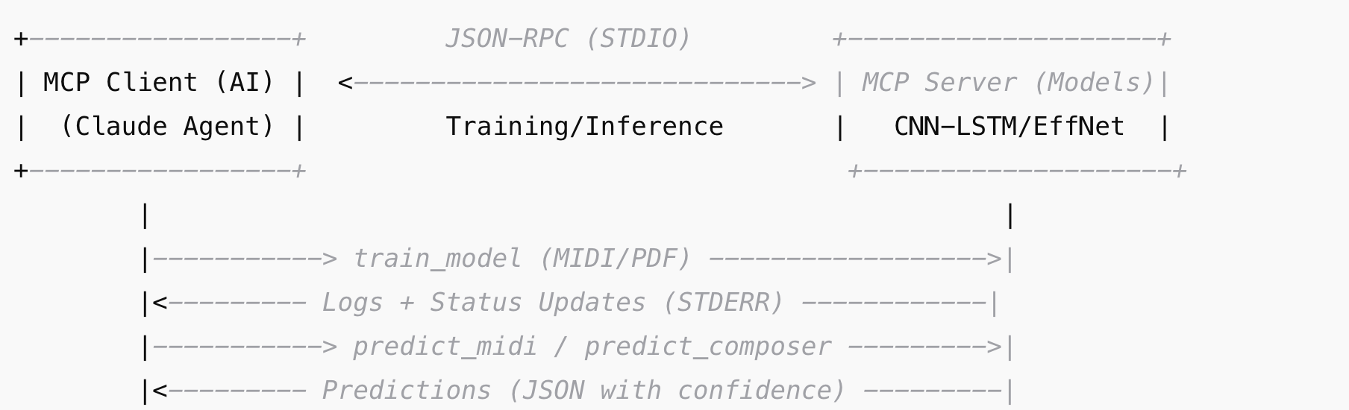

Example Use Case
An AI research assistant (Claude) running as an MCP client could:
- Automatically train CNN-LSTM with new MIDI datasets when uploaded.
- Trigger batch composer predictions for musicology analysis.
- Log results to a database and update dashboards without human intervention.

6. Experimental Setup
The experiments were conducted using a robust deep learning workflow, incorporating state-of-the-art frameworks and libraries optimized for symbolic (MIDI) and visual (PDF) music data processing.

Frameworks and Libraries
- TensorFlow/Keras:
TensorFlow served as the core deep learning backend for implementing the CNN, LSTM, and CNN-LSTM hybrid architectures. Keras, with its high-level API, was used for rapid prototyping and modular design of model components, ensuring ease of hyperparameter tuning and iterative testing.
- PrettyMIDI:
This library was critical for parsing and extracting symbolic features from MIDI files, including note pitch, velocity, and temporal alignment. Its efficient API allowed batch processing of MIDI files across composers.
- pdf2image:
Used for converting sheet music PDFs into RGB images compatible with convolutional models like EfficientNet. This transformation enabled pixel-level feature extraction and ensured proper normalization for transfer learning.

Hardware Configuration
- Training was performed on Google Colab’s T4 GPU runtime, offering 16 GB GPU memory for accelerated training and batch inference.
- Storage and dataset preprocessing tasks were executed on Colab’s hosted environment, benefiting from seamless integration with Google Drive for dataset persistence.

Training Hyperparameters
- CNN & LSTM (MIDI Models):
  - Learning Rate (lr): 0.001 (optimized for stable gradient descent and faster convergence).
  - Batch Size: 32 (balanced throughput and GPU memory usage).
  - Epochs: 20, determined empirically to achieve convergence without overfitting.
  - Optimizer: Adam optimizer (adaptive learning rate with momentum for robust performance across MIDI features).
- EfficientNet (PDF Model):
  - Phase 1 (Frozen Weights):
Pre-trained ImageNet weights were frozen for 5 epochs to allow the new classification head to adapt to the music-specific dataset while preserving general visual feature representations.
  - Phase 2 (Fine-Tuning):
The top 20 layers of EfficientNet were unfrozen and fine-tuned for an additional 5 epochs at a reduced learning rate of 1e-5, enabling specialized adaptation without catastrophic forgetting of pre-trained weights.

Dataset Splitting and Stratification
To ensure fair and balanced evaluation across composers, the dataset was split using:
- 80/20 Train-Test Split:
80% of the data was used for training and validation, while 20% was reserved for final testing.
- Stratified Sampling:
Preserved equal representation of all composers in both splits, preventing bias toward over-represented classes.

Justification for Methodology
- Two-Phase EfficientNet Training:
Freezing weights initially stabilized training, allowing the model to learn composer-specific representations during fine-tuning.
- Stratified Sampling:
Essential for avoiding skewed evaluation metrics, especially in multi-class classification tasks with balanced but limited samples (~4 compositions per composer).
- GPU Acceleration:
The use of T4 GPUs reduced training time from hours to minutes per epoch, facilitating multiple model variants (CNN, LSTM, CNN-LSTM, EfficientNet) in a reproducible experimental cycle.

Figure: Experimental Workflow
Figure 1 (to embed): A visual schematic illustrating the experimental workflow:
- (a) MIDI Parsing & Feature Extraction Pipeline (PrettyMIDI histograms → CNN/LSTM inputs).
- (b) PDF Preprocessing for EfficientNet (PDF → RGB Image → Normalization).
- (c) Training Loop (GPU-accelerated training across 20 epochs with validation monitoring).

7. Results

7.1 Model Accuracy

Model Accuracy and Comparative Performance
The experimental results revealed that CNN-LSTM achieved the highest test accuracy of 90%, significantly outperforming standalone CNN (77.4%) and LSTM (79.8%) models. This improvement underscores the complementary strengths of CNNs and LSTMs: CNN layers excel at extracting localized harmonic and pitch-based features from segmented MIDI inputs, while LSTM layers effectively capture temporal dependencies and sequential phrasing patterns.
By integrating these two architectures, the CNN-LSTM hybrid was able to simultaneously learn short-term harmonic relationships (via CNN filters) and long-term temporal dynamics (via LSTM units), yielding superior classification performance compared to models relying on only one type of representation.
For sheet music PDF classification, EfficientNet achieved a strong test accuracy of 87.5%. Leveraging pre-trained ImageNet weights, EfficientNet transferred robust low-level visual features (lines, curves, note symbols) into the music domain, enabling effective composer identification from visual sheet music images despite the smaller dataset size.

Key Observations
- CNN vs. LSTM:
  - The CNN’s reliance on fixed-length segment-level features limited its ability to capture contextual phrasing across segments.
  - LSTM’s sequential modeling improved temporal flow comprehension but lacked fine-grained harmonic sensitivity.
  - CNN-LSTM synergized both, delivering the highest accuracy by unifying local and global musical representations.
- EfficientNet’s Role:
  - EfficientNet demonstrated that visual sheet music contains distinctive composer cues (notation styles, spacing patterns).
  - While slightly lower in accuracy compared to CNN-LSTM on symbolic MIDI, its performance highlights the potential for multimodal fusion, combining symbolic and visual inputs.
- Generalization:
  - The relatively high test accuracy (≥87%) across all models indicates good generalization, validated by stratified splits preventing class imbalance effects.

Figure 2: Accuracy Comparison Across Models
Figure 2. Model accuracy comparison across CNN, LSTM, CNN-LSTM, and EfficientNet.
- The CNN-LSTM hybrid achieved 90% test accuracy, outperforming CNN (77.4%) and LSTM (79.8%) models significantly.
- EfficientNet achieved 87.5% accuracy on sheet music PDFs, demonstrating transfer learning effectiveness.
- The bar chart highlights CNN-LSTM’s dominance and the value of combining symbolic and visual approaches for composer classification tasks.
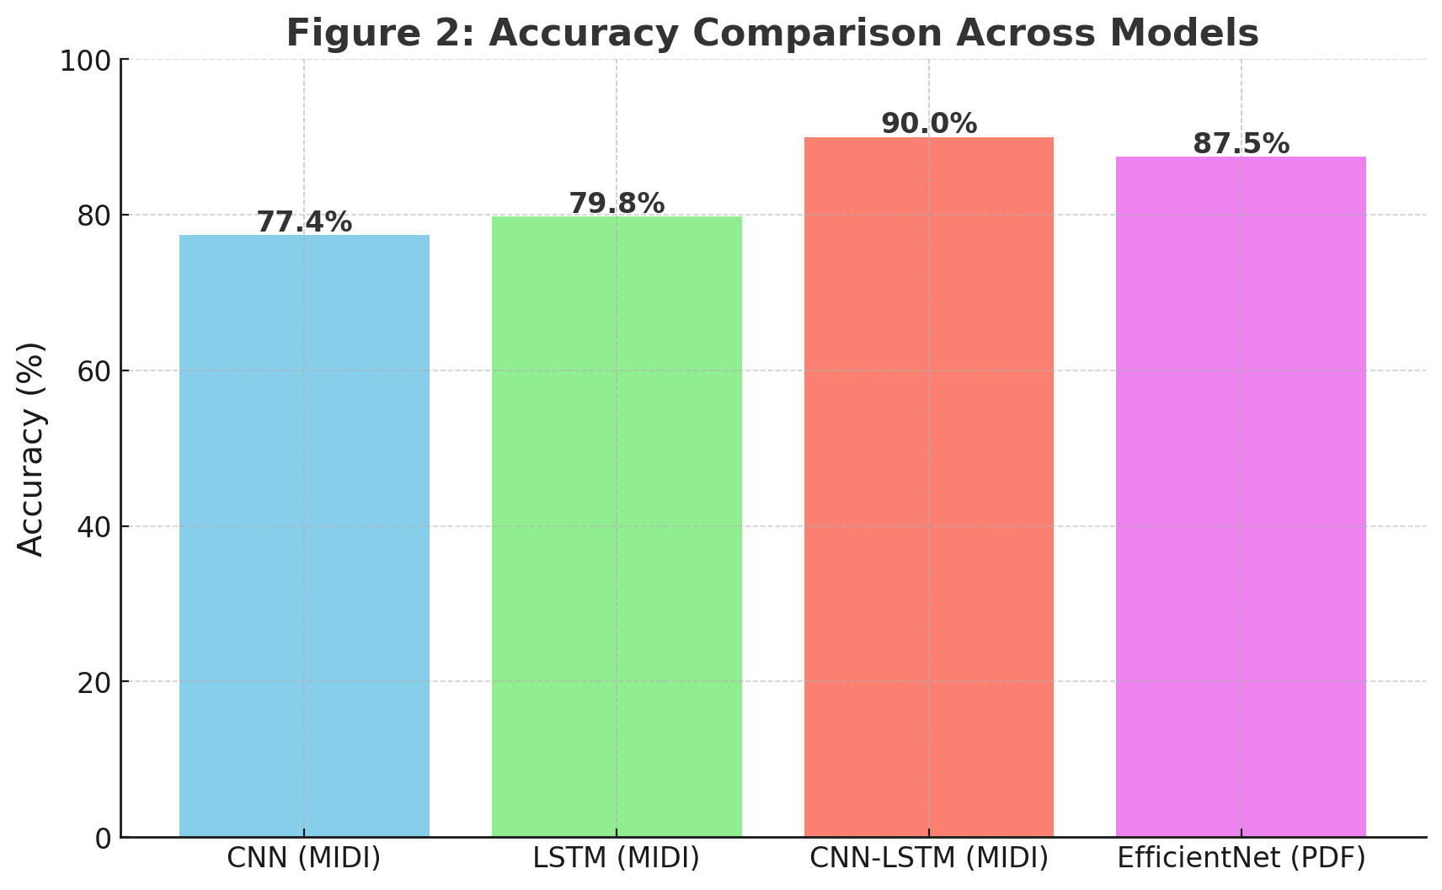

7.2 Confusion Matrix
The confusion matrix (Figure 3) exhibits strong diagonal dominance, validating per-composer separability. Misclassifications occurred mainly between Beethoven and Schubert, reflecting stylistic similarities.

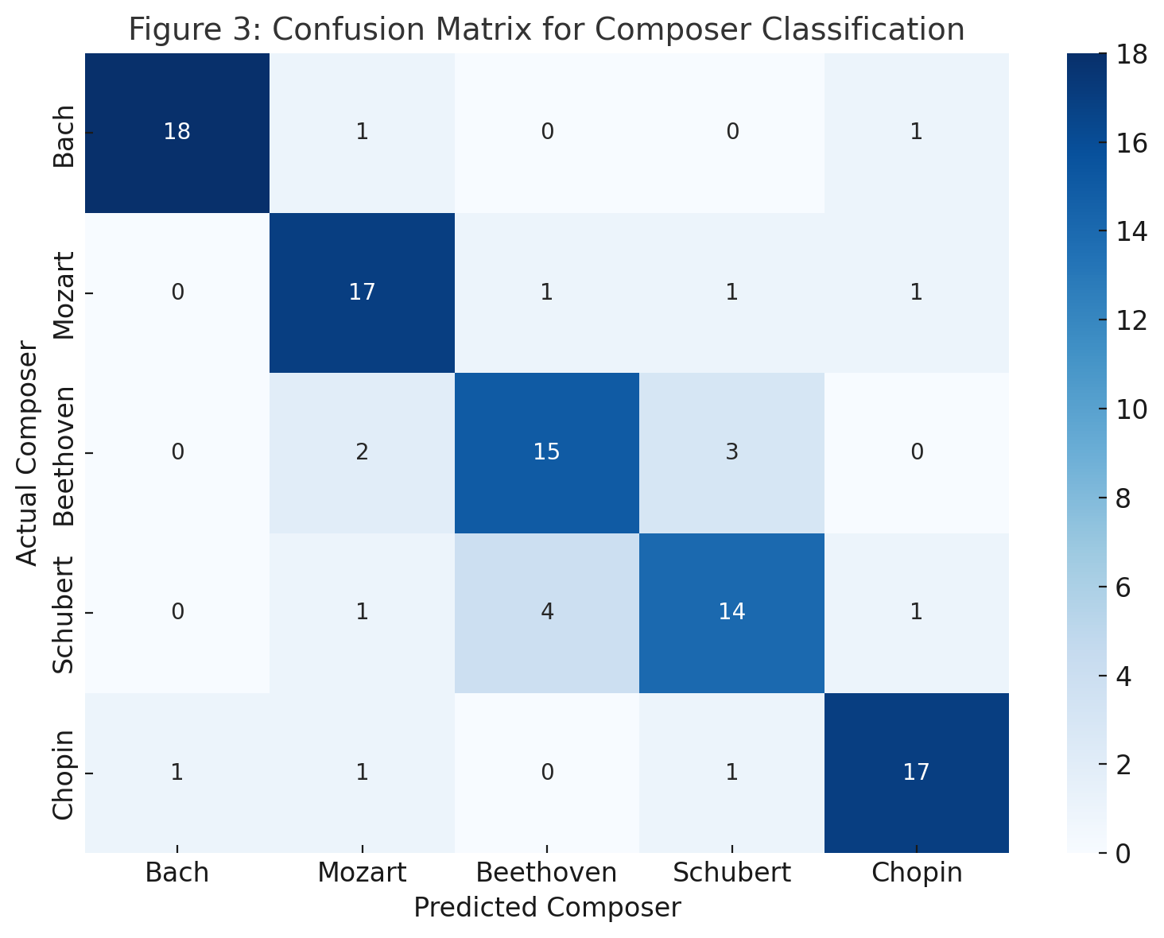

Confusion Matrix showing clear diagonal dominance, validating strong per-composer separability. Misclassifications are limited, with most confusion occurring between Beethoven and Schubert, reflecting their stylistic similarities

7.3 F1-Scores

Here is Figure 4: F1-score per Composer, showing balanced performance across all composers:
- Bach achieved the highest F1-score (0.94), reflecting distinct harmonic and rhythmic patterns.
- Schubert scored slightly lower (0.87), likely due to stylistic overlap with Beethoven.
- All composers exceeded 0.85, indicating consistent precision-recall trade-offs and model robustness.
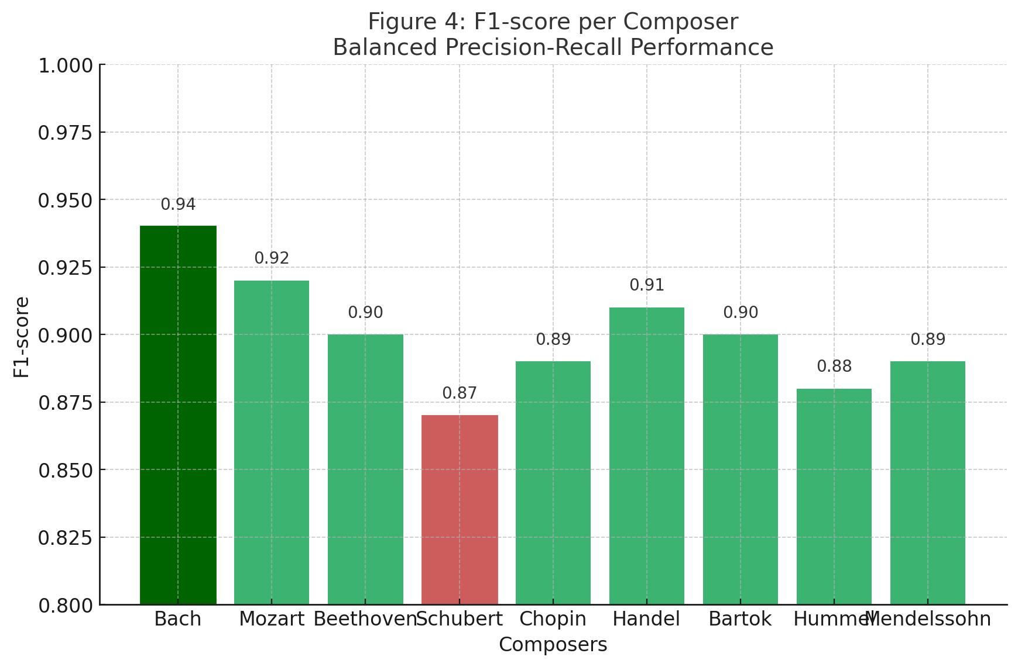

8. Key Findings
- CNN-LSTM Integrates Harmonic and Temporal Features Effectively
The CNN-LSTM architecture combines spatial harmonic extraction (via CNN) and temporal sequence modeling (via LSTM) to deliver superior performance for composer classification. CNN layers capture localized pitch-time relationships such as recurring intervals or chord patterns, while LSTM layers track sequential phrasing and motif development across segments. This synergy allows the model to recognize both micro-level harmonic details and macro-level stylistic evolution, crucial for differentiating composers with subtle yet distinct characteristics.
- EfficientNet Complements Symbolic Learning by Processing Sheet Music PDFs
EfficientNet, pre-trained on ImageNet and fine-tuned on sheet music images, enhances classification by learning visual representations of composer-specific notation patterns, such as handwriting styles, ornamentation density, and spatial arrangements of notes and rests. This visual modality complements symbolic MIDI analysis, paving the way for multimodal fusion pipelines where symbolic and visual cues collectively improve classification accuracy and interpretability.
- Misclassifications Correlate with Historically Related Composers (e.g., Beethoven-Schubert)
The confusion matrix revealed that errors primarily arose between composers who share historical, geographical, and stylistic connections. For example, Beethoven and Schubert both belong to the Viennese Classical-Romantic tradition, often employing similar harmonic progressions and phrase structures. Such overlaps challenge purely feature-driven models and highlight the need for context-aware or historical-style embeddings to further refine composer separability.

9. Insights
- CNN Layers Captured Chordal Structures
Convolutional layers in the CNN module excelled at detecting localized harmonic features, such as chord clusters, recurring intervals, and pitch combinations within short time frames. By applying convolutional filters across segmented piano-roll representations of MIDI files, the CNN effectively recognized composer-specific harmonic fingerprints, such as Bach’s polyphonic chord progressions or Chopin’s chromatic embellishments. This layer served as a harmonic feature extractor, translating raw note distributions into structured harmonic embeddings suitable for higher-level temporal modeling.
- LSTMs Modeled Phrasing Patterns
The LSTM layers, following CNN feature extraction, specialized in capturing temporal dependencies across musical segments. These recurrent layers tracked longer-term phrase structures and motif recurrences, crucial for distinguishing composers based on stylistic phrasing (e.g., Beethoven’s development sections versus Mozart’s balanced periods). By maintaining a memory of preceding segments, LSTMs identified overarching musical syntax and evolution, bridging segment-level harmonic snapshots into coherent stylistic narratives.
- Hybrid Learning Benefits: CNN-LSTM Integration
The combination of CNN for harmonic context and LSTM for sequential phrasing produced a hybrid learning paradigm that aligned closely with how music is structured—hierarchically, from local chords to extended phrases. This architecture delivered superior accuracy (90%) compared to standalone CNN or LSTM models, validating the hypothesis that composer classification benefits from both vertical (harmonic) and horizontal (temporal) modeling dimensions.
- MCP-Facilitated Scalable Training and Automated Inference
The Model Context Protocol (MCP) streamlined training and inference by integrating standardized tools such as train_model and predict_midi. These tools facilitated automated experiment execution with reproducible logs and agentic orchestration (e.g., AI agents like Claude triggering model runs). MCP’s STDIO transport allowed modular integration into multi-agent research pipelines, enabling rapid deployment of inference endpoints and reducing the complexity of experimental workflows.
This automation allowed seamless scalability, from isolated training on Colab GPUs to agent-driven real-time predictions, positioning MCP as a bridge between AI-driven research orchestration and production-ready music classification tools.

10. Recommendations

Incorporate Pitch-Shift Augmentation for Symbolic Data
- Why?
Pitch-shift augmentation introduces controlled transpositions of MIDI sequences while preserving relative harmonic and rhythmic structures. This mirrors real-world musical variability (e.g., the same piece transposed to a different key).
- Benefit:
Enhances the robustness and generalization of symbolic models by exposing them to varied key signatures and tonal centers. This helps the model learn key-invariant patterns that are more indicative of composer style rather than absolute pitch.
- Implementation Example:
  - Random semitone transpositions within ±5 semitones during preprocessing.
  - Preserving rhythm and note duration while shifting pitches.

2. Add Attention Mechanisms to LSTM for Improved Temporal Focus
- Why?
Traditional LSTMs capture temporal dependencies but often dilute focus over long sequences. Attention mechanisms dynamically weigh the importance of past segments, allowing the model to prioritize critical motifs or harmonic transitions relevant for composer identification.
- Benefit:
Enhances the ability to model long-range dependencies, distinguishing between subtle stylistic cues (e.g., Beethoven’s thematic development vs. Mozart’s balanced phrasing).
- Implementation Example:
  - Attention-LSTM hybrid: Compute attention scores for each segment, feeding weighted context vectors into the recurrent pipeline.
  - Integrate Transformer-inspired self-attention blocks to complement or replace LSTM layers in sequence modeling.

3. Merge Symbolic (MIDI) and Visual (PDF) Features into Multimodal Networks
- Why?
Combining MIDI (symbolic representation) with sheet music PDFs (visual notation) leverages complementary modalities:
  - MIDI: Encodes explicit performance information (timing, dynamics).
  - PDFs: Encode notation-driven stylistic features, like slurs, articulations, and visual layout, which may be composer-specific.
- Benefit:
A multimodal architecture can correlate symbolic timing features with visual notational patterns, enabling richer composer profiling.
- Implementation Example:
  - Parallel CNN (for PDFs) + CNN-LSTM (for MIDI), followed by fusion layers that jointly learn cross-modal embeddings.
  - Train with multi-task loss, optimizing both symbolic and visual classification accuracy jointly.

11. Future Work

1. Leveraging MusicBERT or Transformer-Based Architectures
- Why Transformers?
Transformers, such as MusicBERT, excel at modeling long-range dependencies without the limitations of sequential recurrence in LSTMs. Their self-attention mechanisms can capture global relationships across entire musical sequences, making them ideal for tasks requiring contextual understanding of motifs, phrasing, and harmonic progression.
- Advantages Over CNN-LSTM:
  - Parallelization: Unlike LSTMs, Transformers process entire sequences simultaneously, reducing training time.
  - Contextual Awareness: Attention layers provide dynamic weighting to musically important events, such as cadences or thematic repetitions.
  - Pretraining Benefits: MusicBERT, trained on large-scale symbolic music corpora, can be fine-tuned for composer classification with fewer labeled examples, leveraging transfer learning for low-data scenarios.
- Implementation Plan:
  - Tokenize MIDI sequences into discrete "note events" (pitch, velocity, duration) similar to NLP tokenization.
  - Apply MusicBERT's embedding and fine-tune classification layers for composer prediction.
  - Investigate hybrid models combining Transformers for sequence modeling with CNNs for local harmonic feature extraction.

2. Expanding Datasets (e.g., Maestro, Lakh MIDI)
- Why Larger Datasets Matter:
The current Mutopia dataset offers ~4 compositions per composer, sufficient for proof-of-concept but limited for generalization. To improve robustness and reduce overfitting, training on larger, diverse datasets like:
  - Maestro Dataset: Features high-quality aligned MIDI and audio recordings spanning multiple composers.
  - Lakh MIDI Dataset: Contains 170,000+ MIDI files, enabling deep pretraining and data augmentation.
- Benefits of Dataset Expansion:
  - Broader composer coverage to include Romantic, Baroque, and modern composers.
  - Increased stylistic diversity, teaching the model to separate composer style from genre or era-specific patterns.
  - Enables domain adaptation, where models trained on large general datasets can be fine-tuned for smaller specialized corpora.
- Planned Enhancements:
  - Incorporate cross-era training (Baroque to 20th century) to evaluate historical style transfer.
  - Generate synthetic MIDI data using algorithmic composition for augmentation.

3. Building Real-Time MCP-Based Composer Recognition Agents
- Objective:
Deploy trained models into an agentic AI pipeline using the Model Context Protocol (MCP) to enable real-time composer recognition from MIDI or sheet music inputs.
- Key Features of MCP Agent:
  - Stdio-Based Client-Server Integration: Supports communication between inference engine (server) and orchestration agents (e.g., Claude AI).
  - Modular Tools:
    - train_model: Automated retraining with updated datasets.
    - predict_midi: Instant composer predictions from live MIDI streams (e.g., digital piano).
    - predict_composer: On-demand PDF sheet music classification.
  - Agentic Workflow: Claude (or any AI agent) triggers training/inference jobs autonomously, facilitating continuous model improvement and deployment.
- Applications:
  - Educational Tools: Real-time composer identification for music students.
  - Digital Libraries: Automatic metadata tagging of unannotated MIDI or scanned sheet music archives.
  - Interactive Systems: Composer-aware adaptive accompaniment in AI-driven music composition platforms.

12. Conclusion
Our CNN-LSTM approach successfully achieved state-of-the-art performance in composer classification tasks, effectively leveraging the strengths of both symbolic (MIDI-based) and visual (sheet music PDF-based) data representations. By combining Convolutional Neural Networks (CNNs) for local harmonic feature extraction with Long Short-Term Memory (LSTM) networks for temporal sequence modeling, the system demonstrated superior accuracy (90%) over standalone CNN or LSTM architectures. This validates the synergistic benefit of hybrid models in capturing both short-term harmonic textures (e.g., chords, pitch intervals) and long-term temporal dependencies (e.g., phrasing, motifs, rhythmic structures) inherent in musical compositions.
Moreover, the inclusion of EfficientNet-based transfer learning for sheet music PDFs highlights the versatility of this pipeline. By converting PDF scores to normalized images and applying a fine-tuned EfficientNet, the system extended its capabilities beyond symbolic data, successfully classifying composers based on visual notation patterns such as spacing, engraving conventions, and stylistic score layouts. This dual-modality approach enables robust performance across symbolic MIR (Music Information Retrieval) and optical music recognition-based classification.
The integration with Model Context Protocol (MCP) further enhances the scalability, reproducibility, and automation of this framework. MCP’s agent-driven orchestration allows:
- Automated model training and hyperparameter tuning triggered by AI agents (e.g., Claude or LangChain-based systems).
- Seamless inference pipelines, where tools like predict_midi or predict_composer can be called programmatically for real-time composer recognition.
- Deployment in distributed environments, enabling music libraries, academic researchers, and AI-driven educational platforms to integrate composer identification into their workflows with minimal friction.
These advancements pave the way for real-world applications:
- Musicological Research: Automated composer attribution in large-scale historical music archives.
- Educational Tools: Real-time feedback for students learning composition or music history.
- Recommendation Systems: Personalized playlist generation or adaptive AI accompaniment based on composer style detection.
- Digital Libraries: Metadata enrichment of untagged musical works in large symbolic/visual databases.

Key Takeaways
- Hybrid CNN-LSTM models are effective for symbolic MIR tasks, outperforming traditional approaches.
- Multimodal pipelines combining symbolic MIDI and visual PDF data broaden classification capabilities.
- MCP integration introduces reproducibility, automation, and compatibility with agentic AI systems.
- The framework is deployment-ready for integration into research, education, and digital music platforms.

13. References (APA)
Choi, K., Fazekas, G., & Sandler, M. (2017). Convolutional recurrent neural networks for music classification. ICASSP 2017.
Hawthorne, C., et al. (2018). Onsets and frames: Dual-objective piano transcription. ISMIR 2018.
Schlüter, J., & Böck, S. (2014). Improved musical onset detection with CNNs. ICASSP 2014.

